Joel Adame

Complex Instrument Recording Report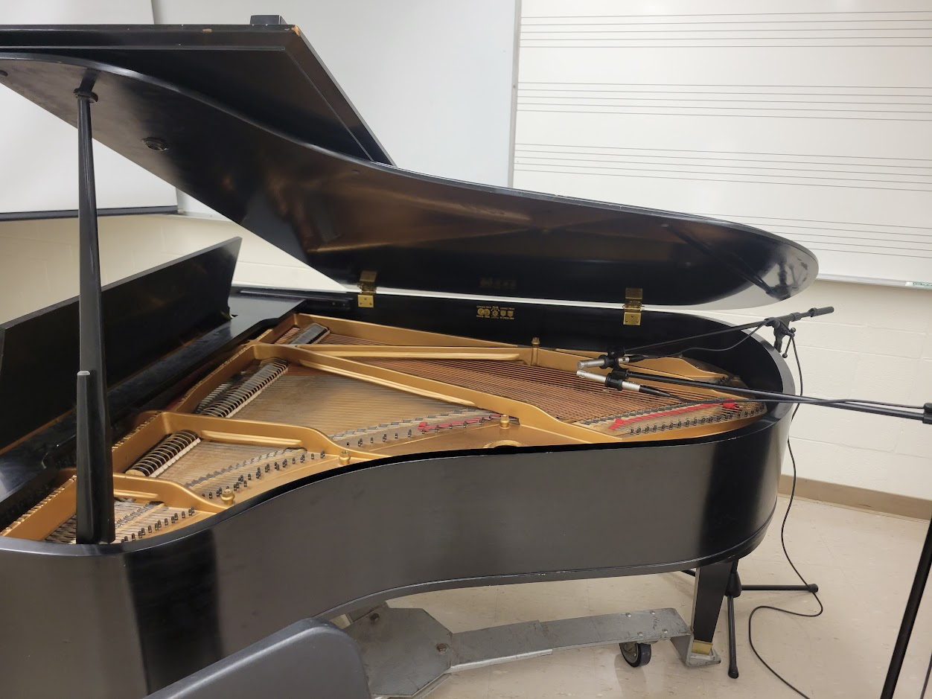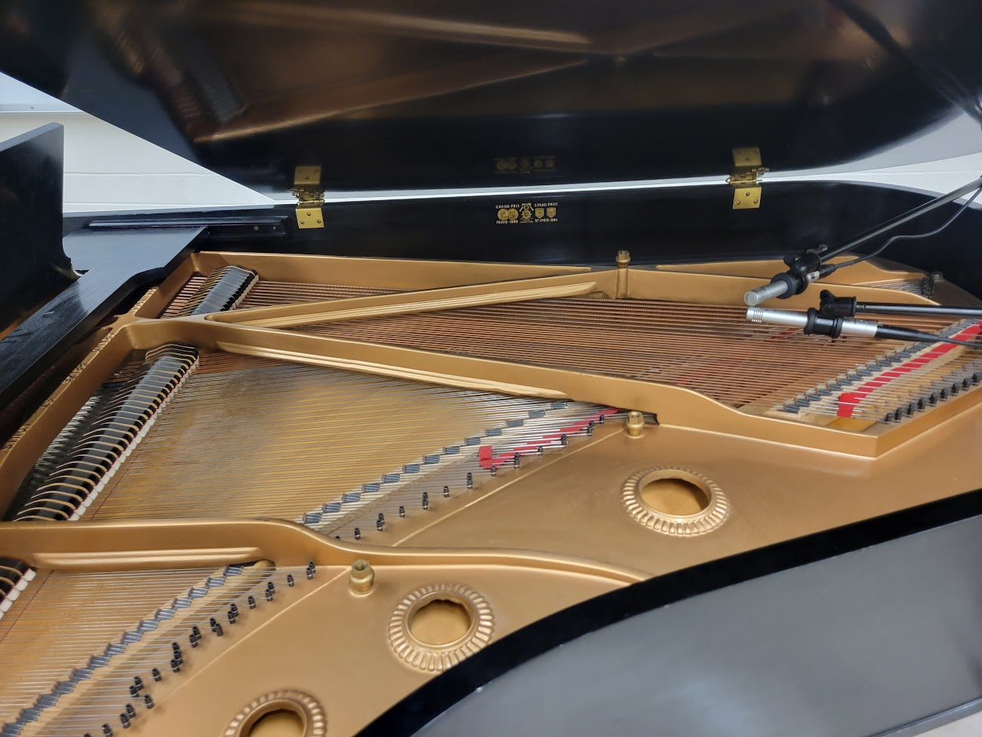

Samson C02 mics were used in both setups, in X/Y coincident stereo.

Setup 1:

The setup for the first recording was as shown in the images above, with the lid fully opened and the microphones at the back of the piano in a coincident pair. One microphone was aimed more at the lower strings, the other more on the higher strings. That setup mixed with the piece played showed a nice stereo image, although not quite as wide as I might’ve wanted with this piece specifically. A very nice and direct image.



Setup 2:

The setup for the second recording was still a coincident pair, but spaced away to the side of the piano to get more room noise. The piano was still fully open, and the mic was about 5.5 feet up and 4 feet away from the piano. This gave a nice bit of room, but also let in a little bit of HVAC noise. I first tried it a little farther, but there was too much noise with that setup so I brought it in a little closer.

Both audio files were brought up to normalization a little, but no EQ or compression was added. I had forgotten my headphones again, but luckily the music department studio was nearby to grab a pair of ATH-M40x headphones for monitoring.