Monitor Set Up Report
Joel Adame and Kenia Flavius
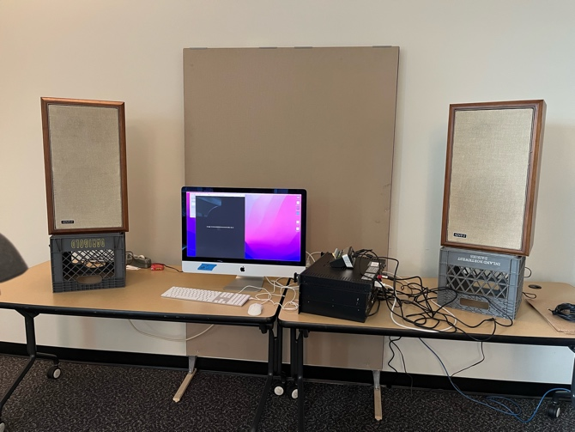
First, Joel and I set up the speakers, putting them on the milk crates to get them off the table. This got rid of a lot of first reflections. We then placed the mic on a stand and positioned the speakers and mic in an equilateral triangle. We placed the spectrum analyzer on a table in front of the monitors and computer, plugging it into the nearest outlet and closing the blinds to make it easier to see. The speakers got plugged into the amplifier and the audio interface, but the pink noise wasn't coming through the speakers. We found out the amplifier wasn't plugged in to power, so in the future remember to check everything is turned on and plugged in. We started with the left speaker using pink noise and the spectrum analysis. We used a short pink noise file until we found a longer 3 minute one, which was better. We started with a lower gain, finding the most out of place frequencies, and then slowly increased it as we continued. While flattening the frequency response we discovered the spectrum analysis registers frequencies lower than the EQ on the amplifier. The EQ only went down to 31.5Hz, but the analyzer went into the 20s. We decided the speaker wasn't giving enough bass, even with EQ, so we moved the speakers back towards the wall to give it more resonance. Moving the speakers back really helped boost the bass response, as well as adding a warmer sound. Most of the highs, from 1.25k to 12.5k, needed to be turned down a little bit. 16k however needed to be boosted quite a bit. Most of the other frequencies needed small adjustments here and there, which left the EQ in a ‘u’ or ‘smilie face’ shape. This EQ shape however, can cause issues due to the speaker’s design. By forcing the speaker to push out frequencies it normally passes, over a long period of time, the speaker will overload due to being overworked. This will lead to the speaker heating up, causing the interior to melt. Cutting out those frequencies allows the speaker to ignore them completely, avoiding the issue of overworking the speaker. We also forgot to check the HPF on the EQ and note its levels. The HPF was set to 40, and we had boosted 40Hz. Adjusting the HPF would have fixed this problem, although leaving it around 30Hz would still be good for the speaker. We also confirmed the speakers' high frequency control was on extended (8 OHMS) using the switch on the back of the speakers. Once we had a relatively flat analysis, we turned the gain up on the analyzer and continued to look for too high or too low frequencies to adjust. We also moved the mic a little bit to ensure we put it in the best location.
Before
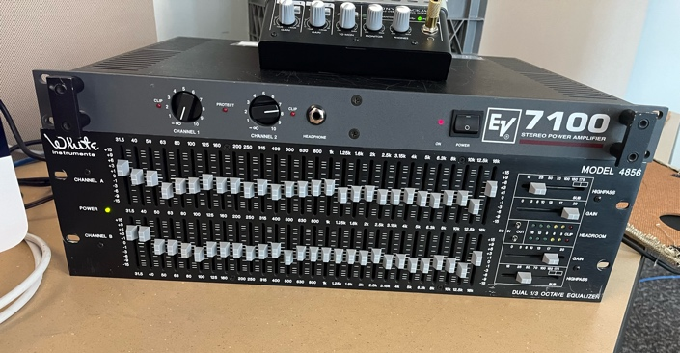
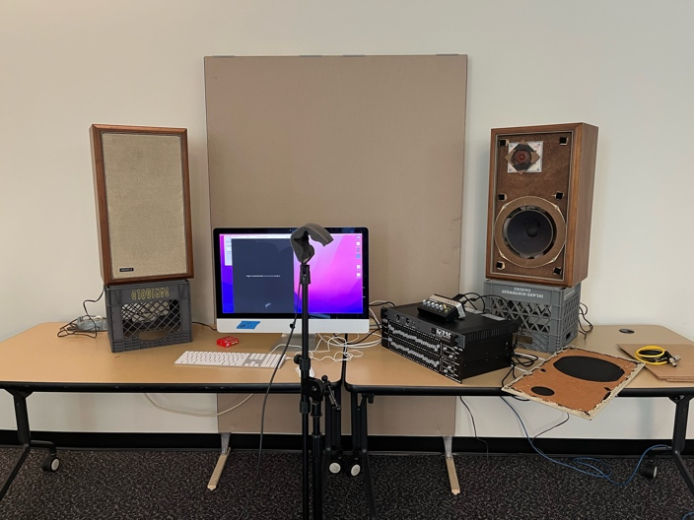
We then did the same process for the right speaker, starting with a lower gain and looking for too high or low frequencies. The adjustments for the left and right speaker were fairly similar. We were able to get through most of the EQ adjustments until the speaker gave out. We heard a rattling noise, along with a metallic clicking. You could also see the speaker cover moving because of the pieces inside being thrown around. We found out the speakers broke due to prolonged use and being old. Luckily to fix it you just had to replace the outer shell of the speaker.
After

